# Native Python & Virtual Environment setup

The below doc with help you setup a Python virtual environment after you install Native Python 3.10 from software center.

* In your command prompt Change the Directory to `C:\Users\YOUR_CDSID\AppData\Local\Programs\Python\Python310`
  + Replace YOUR_CDSID with your actual CDSID

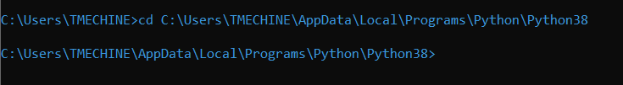

* Create a new directory so, you can store all your virtual env’s in this folder, In my case I created once called (ford-venvs). This way your virtual environments are organized in one place and can be deleted along with your **Python UnInstall**
  + mkdir ford-venvs
  + cd ford-venvs

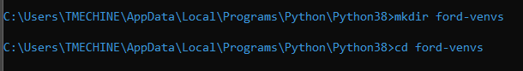

* Create a new virtual environment using the below command (you will see a folder created inside ford-venvs folder). **You can call your env, whatever you want.**
  + python -m venv py310_jupyter_spyder_env

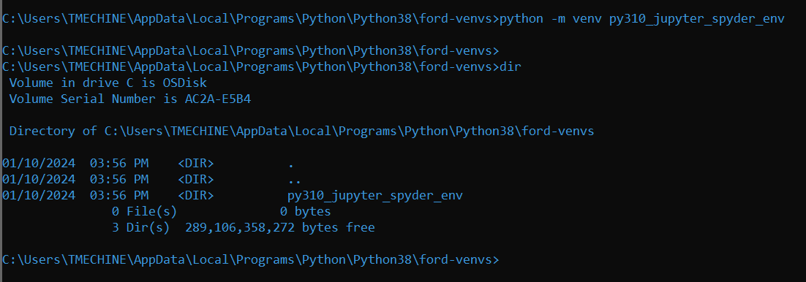

* Activate the virtual environment with the below command.
  + py310_jupyter_spyder_env\Scripts\activate.bat
  + You would see the environment activated, as you see to the left of the terminal.

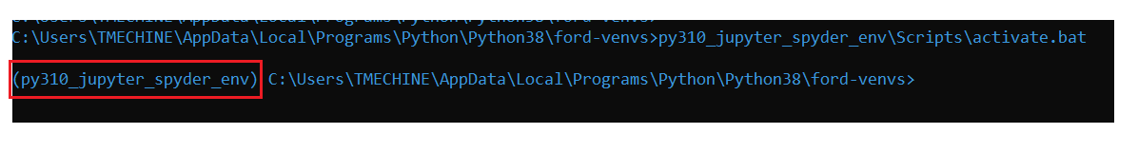

* Verify your Python version and path to the executable (should be from ford-venvs\<your_env>\ folder.

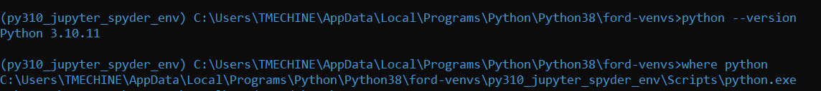

* Install the required packages to start working with Jupyter notebook and Spyder.
  + I am keeping this simple to install only Jupyter and spyder specific dependencies.
  + pip install jupyterlab ipykernel spyder spyder-kernels
  + This process can take up to 10 mins.
  + Once your get the prompt back, register a new kernel to use.

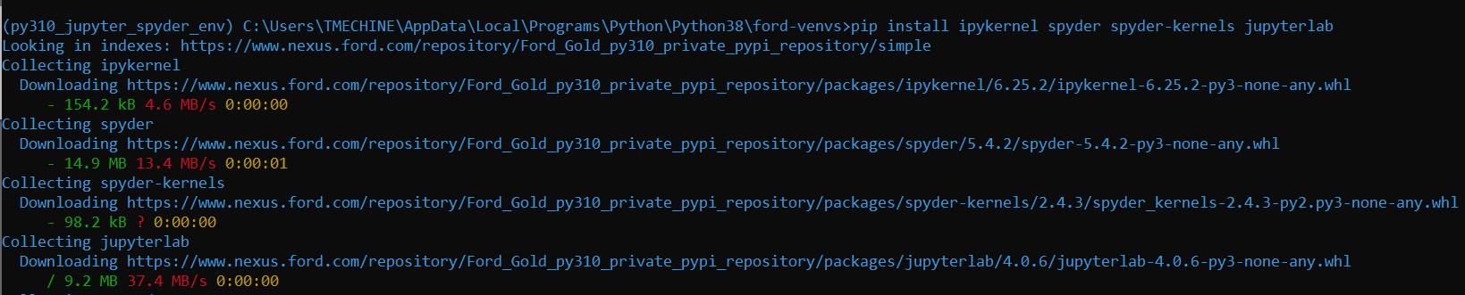

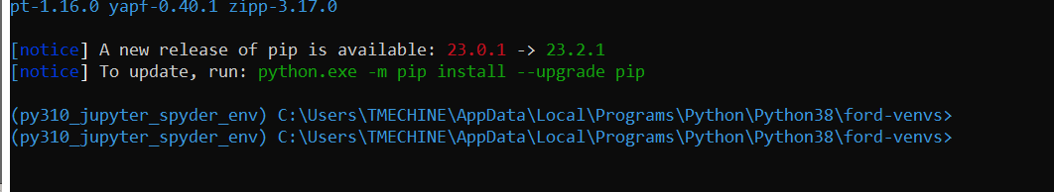

* Kernel setup, run the below command
  + python -m ipykernel install --user --name="py310_jupyter_spyder_env_k"



* Check if the kernel is installed properly.
  + jupyter kernelspec list

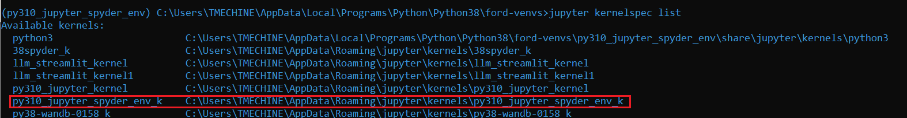

* Now we are ready to check Jupyter lab.
  + In your command prompt, with virtual environment activated run ` python -m jupyterlab`

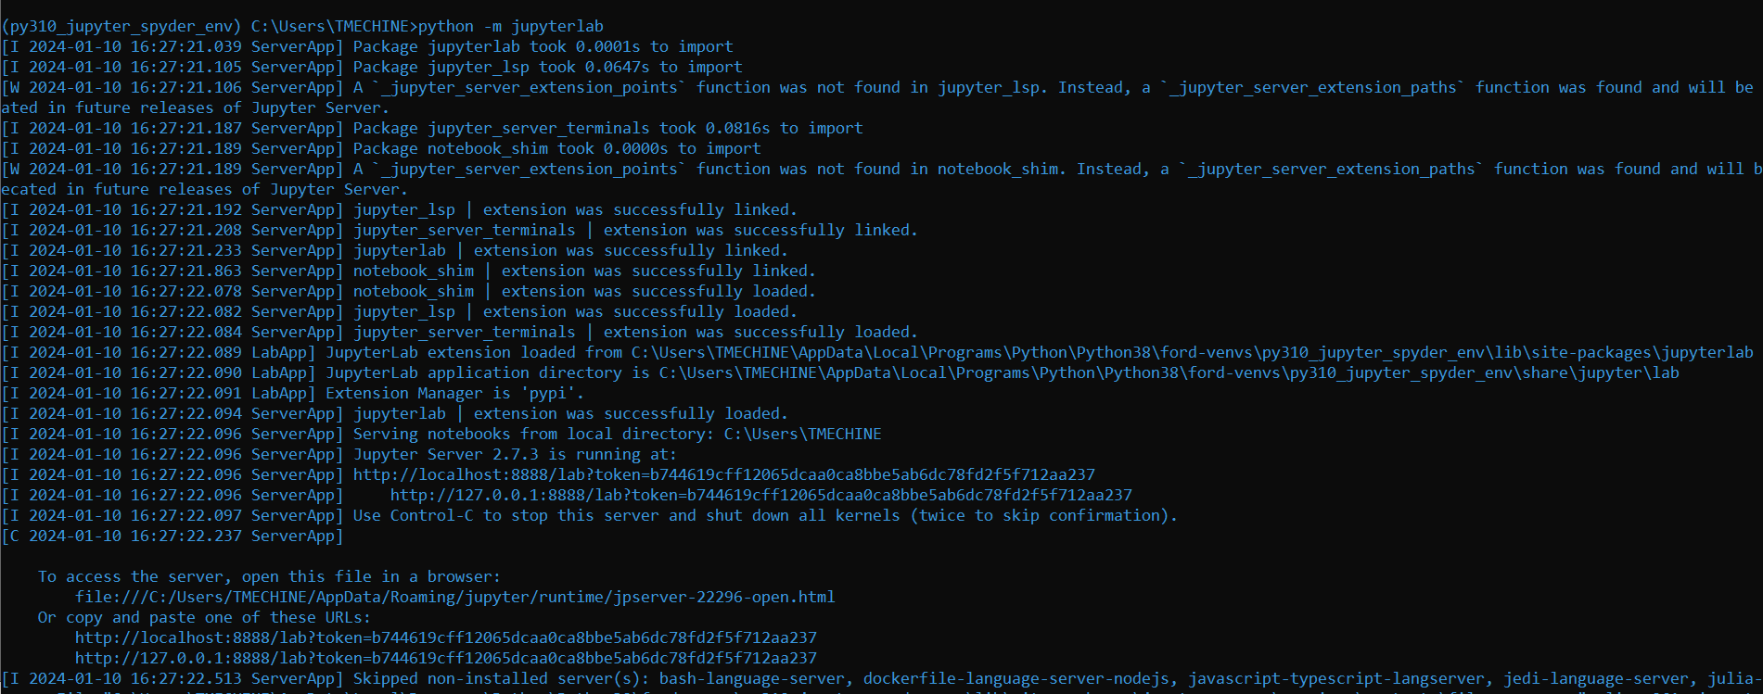

* Make sure to select the right kernel and test a package import by importing paramiko and verifying the path to the package.

import paramiko

print(paramiko)

print(paramiko.__version__)

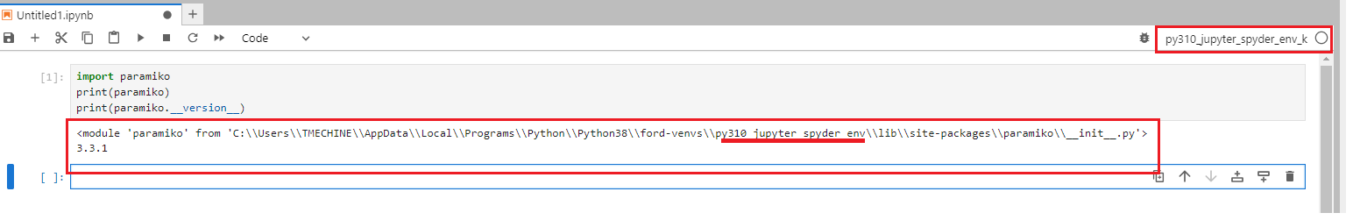

* Now we are ready to check Spyder IDE.
  + In your command prompt, with virtual environment activated run `spyder`
  + Import paramiko (in your console to test it)

